# CS 255 System Design Document

## UML Diagrams

### UML Use Case Diagram

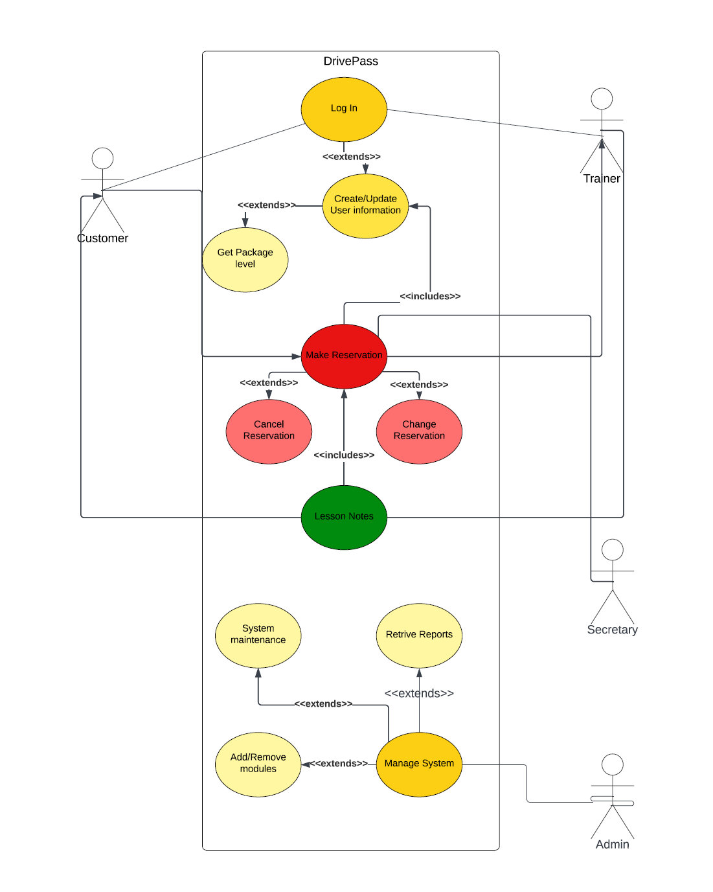

### UML Activity Diagrams

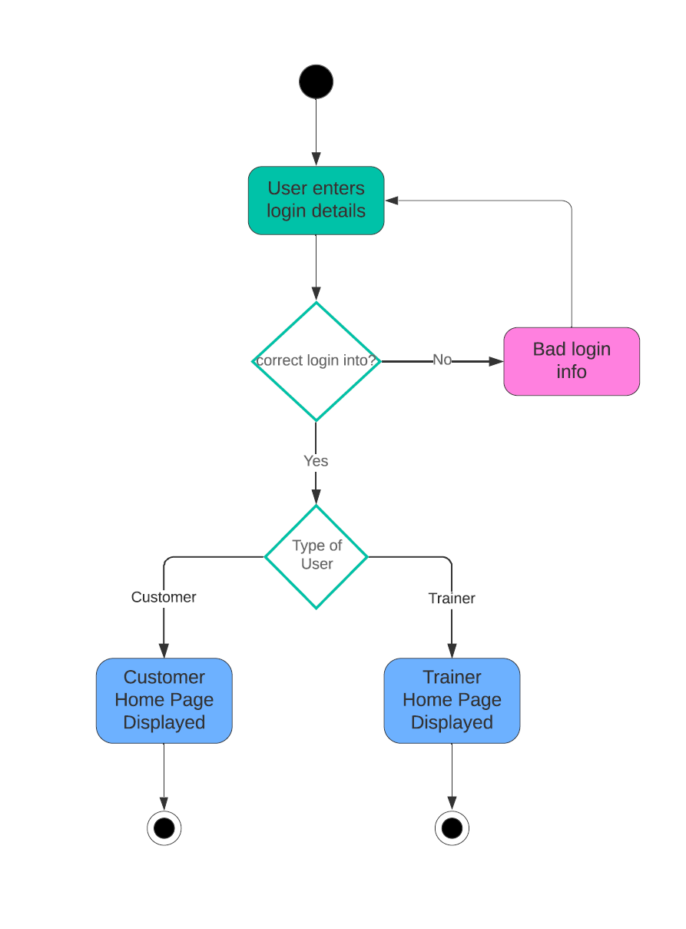

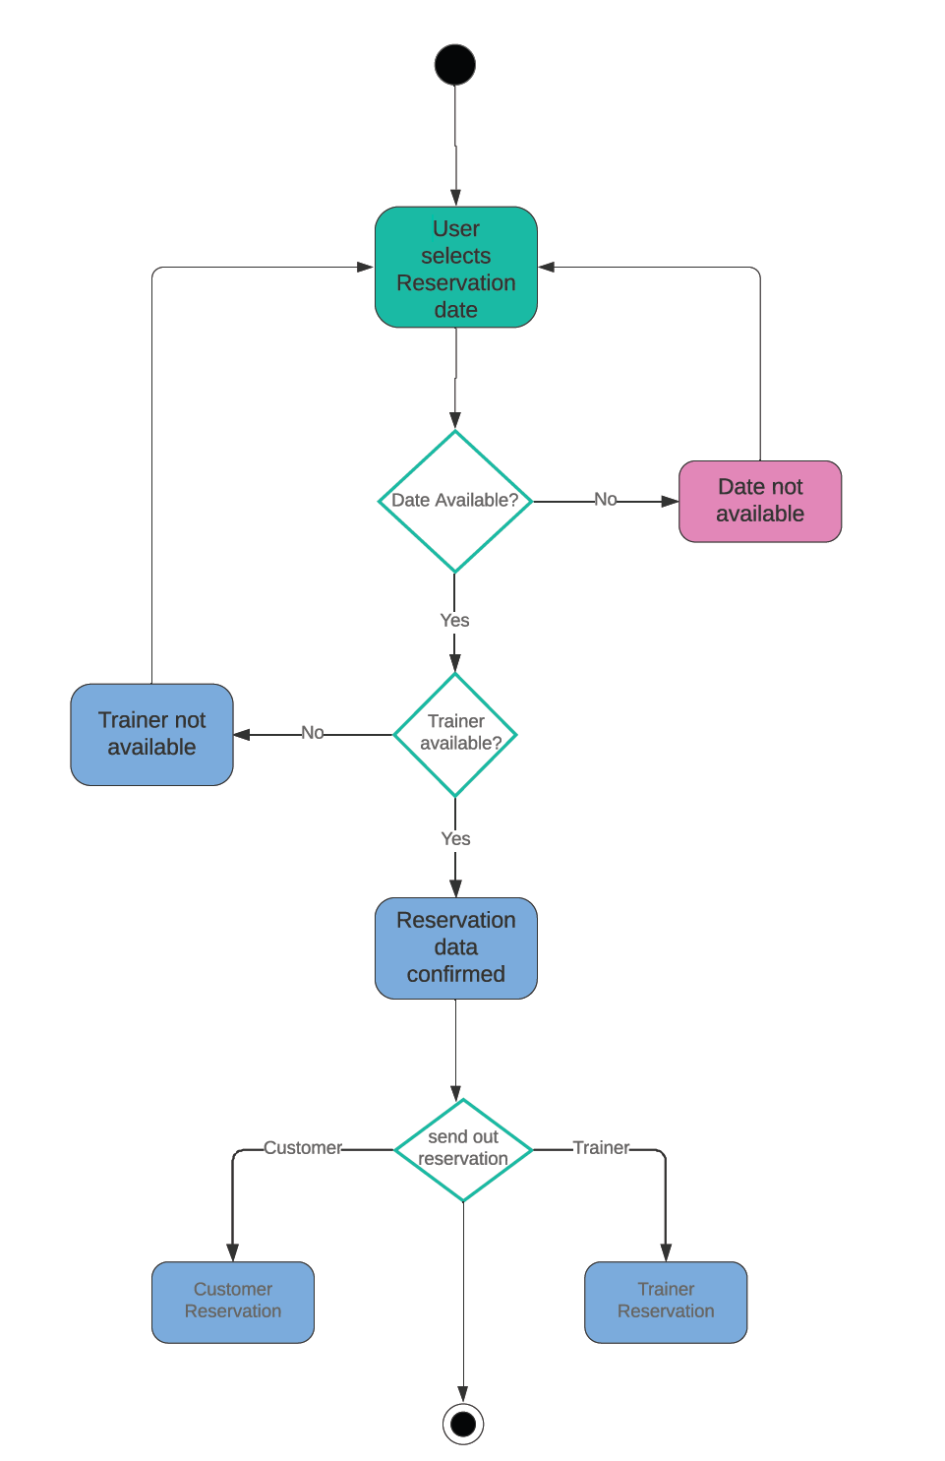

### UML Sequence Diagram

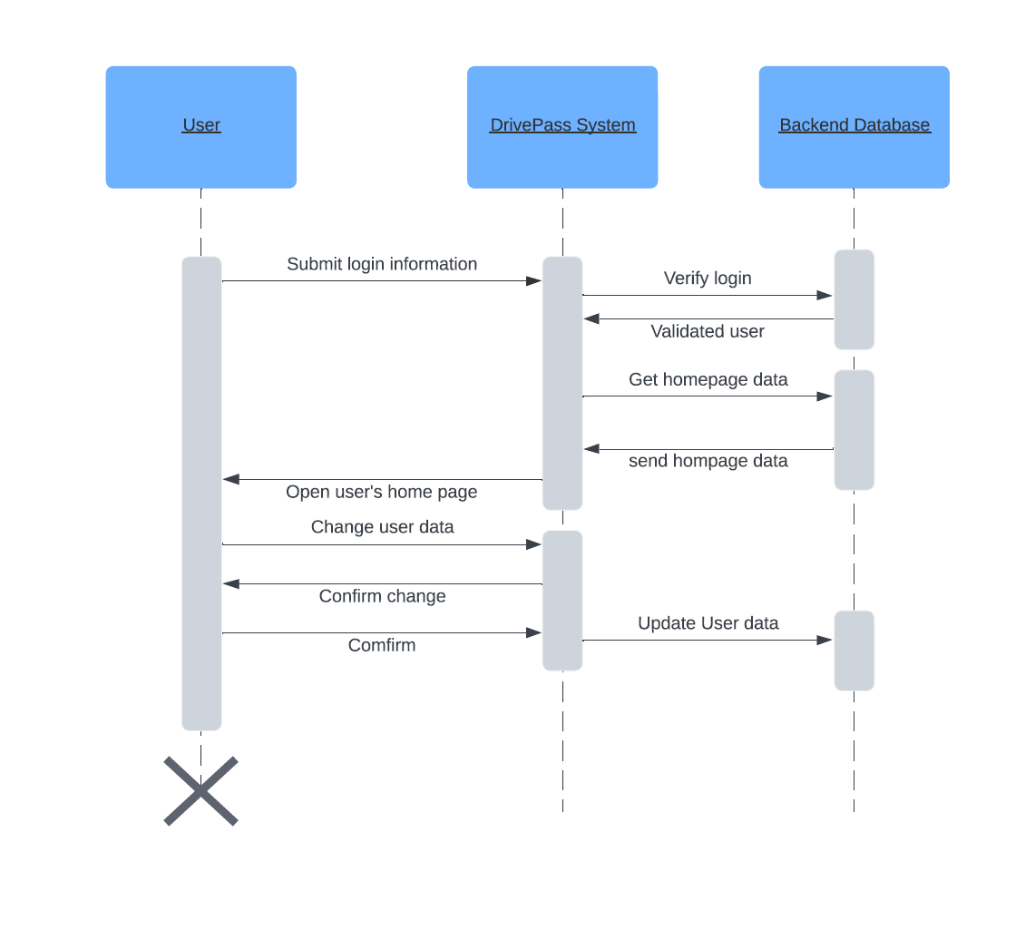

### UML Class Diagram

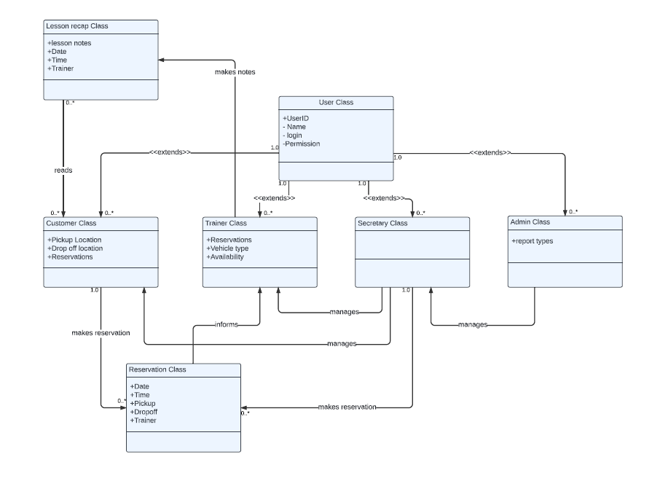

## Technical Requirements

There are a number of technical requirements to ensure that the system can work as intended. These include a cloud based infrastructure that can support a web server, user databases, system databases and process servers, authentication services, reservations and calendar databases. This server infrastructure requires IP connectivity to and ISP and local workstations for access to management activities. This system will requires a firewall device, router, and switch for interconnectivity both between servers as well as the internet. The majority of servers and databases should be hosted as virtual machines to provide a central hub, via a web interface, from which the IT administrator can manage and administer system server. Using Linux based servers and SQL databases hosted on the cloud would provide the most robust platform for the DrivePass system.